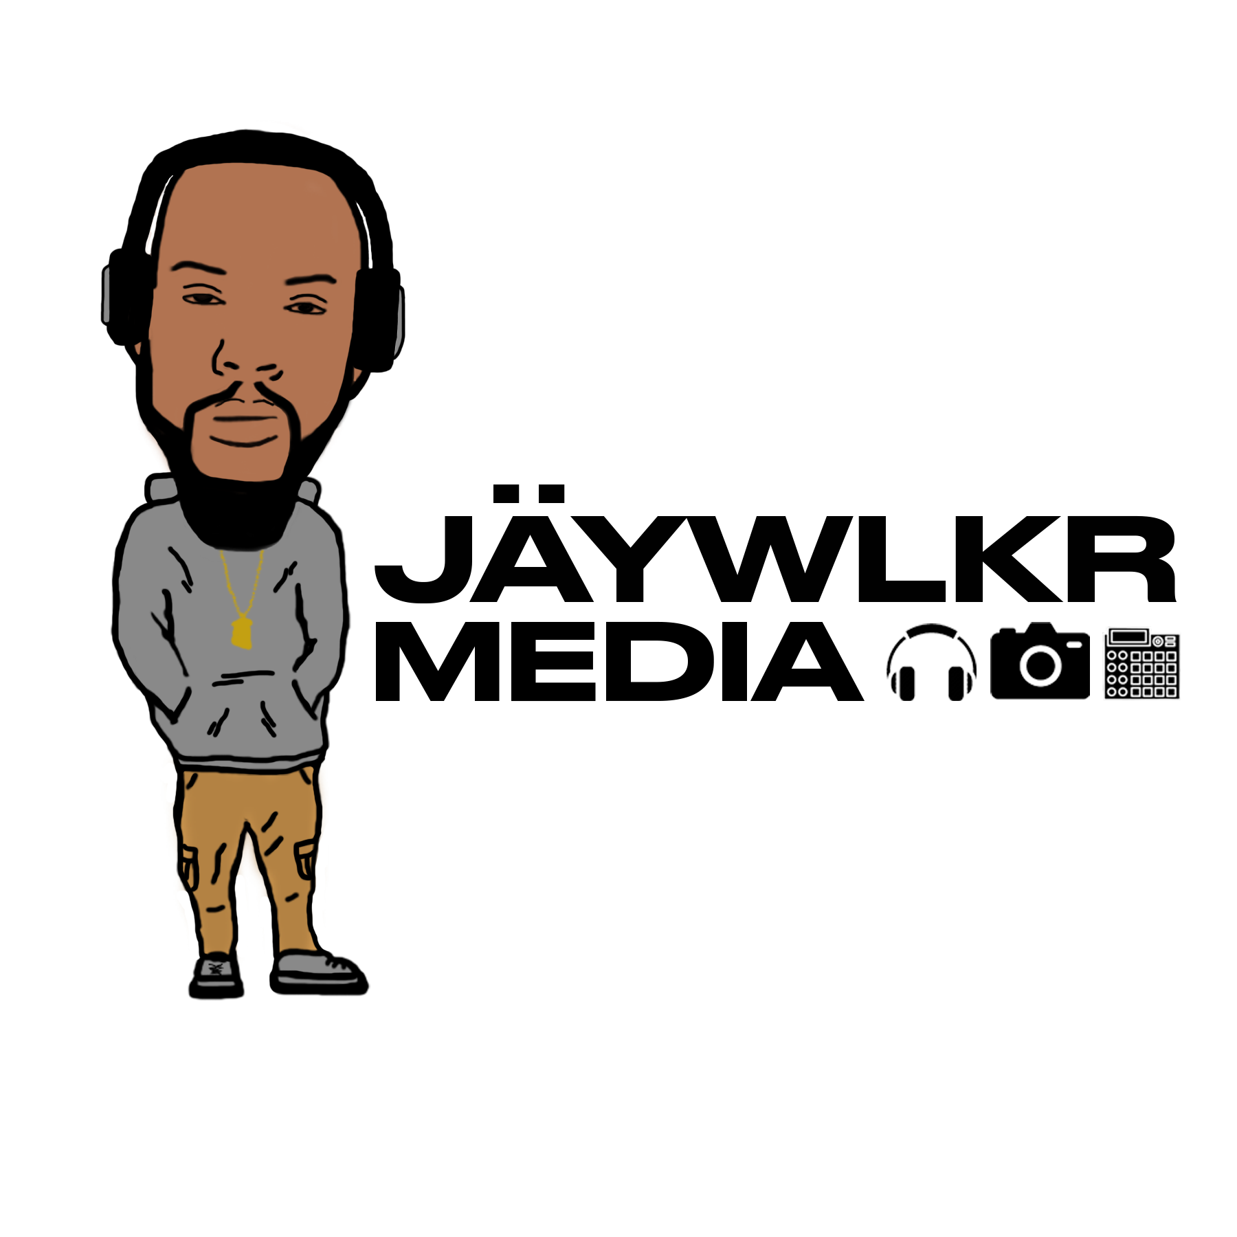

Master Use and Synchronization License
This Master Use and Synchronization License Agreement (the “Agreement”) is made between: [enter name of songwriter/owner of master recordings] (“Licensor”) and [enter name of filmmaker] (“Filmmaker”).

Ownership and Administration of Rights
Licensor is the copyright owner of the following:
master recordings (“Masters”):
[enter titles of master recordings]
compositions (“Compositions”):
[enter titles of compositions]
Rights for the Compositions [] are [] are not administered by a Performing Rights Organization. If they are administered by a PRO, that PRO is: [name the Performing Rights Organization]

Terms of Use
Filmmaker is interested in licensing the Masters and Compositions for the following audiovisual production (“Production”):
[enter title of Production]
The Production will be distributed in the following Territory: [enter where the Production will be distributed; i.e. “United States” or “Worldwide”]
Filmmaker’s License to use the Masters and Compositions will last for the following Term: [enter how long the license will last]

Modifications to Compositions
Filmmaker shall not make any change in the original lyrics, if any, or in the fundamental character of the music of the Compositions without written prior authorization from Licensor.

Nonexclusive License
Licensor grants to Filmmaker and Filmmaker’s successors and assigns the nonexclusive right to use and reproduce the Masters and Compositions solely in synchronization with the Production within the Territory and during the Term. Licensor grants to Filmmaker the right to publicly perform the Masters and Compositions solely in synchronization to the Production.

Payment
Filmmaker shall pay Licensor $[enter fee] for the rights granted in this Agreement.
Payment shall be made [enter payment terms] .

Warranty
Licensor warrants that it has the power and authority to grant the rights in this Agreement and that the Masters and Compositions do not infringe any third-party rights. In no event shall Licensor’s liability for a breach of this warranty exceed the amount of payments received under this Agreement.

Credits
Licensor shall receive credit in the following form: [enter any credit due, using specific language for the credit itself, and stating exactly where credit(s) will appear] .

Cue Sheets
Filmmaker agrees to furnish Licensor a Cue Sheet of the Motion Picture within thirty (30) days after the first public exhibition of the Motion Picture.

Miscellaneous
This Agreement may not be amended except in a writing signed by both parties.
If a court finds any provision of this Agreement invalid or unenforceable, the remainder of this Agreement shall be interpreted so as best to effect the intent of the parties.
This Agreement shall be governed by and interpreted in accordance with the laws of the State of [enter the state where any litigation would be filed] . If a dispute arises under this Agreement, the parties agree first to try to resolve the dispute with the help of a mutually agreed-upon mediator in [enter the city and state where mediation would occur]. Any costs and fees other than attorney fees associated with the mediation shall be shared equally by the parties. If the dispute is not resolved within 30 days after it is referred to the mediator, any party may take the matter to court.

Signatures
Licensor | Filmmaker
Signature: _________________________  Name: _________________________  Title: ____________________________  Mailing Address:  Date: ____________________________ | Signature: ______________________  Name: _________________________  Title: _________________________  Mailing Address:  Date: ______________________

