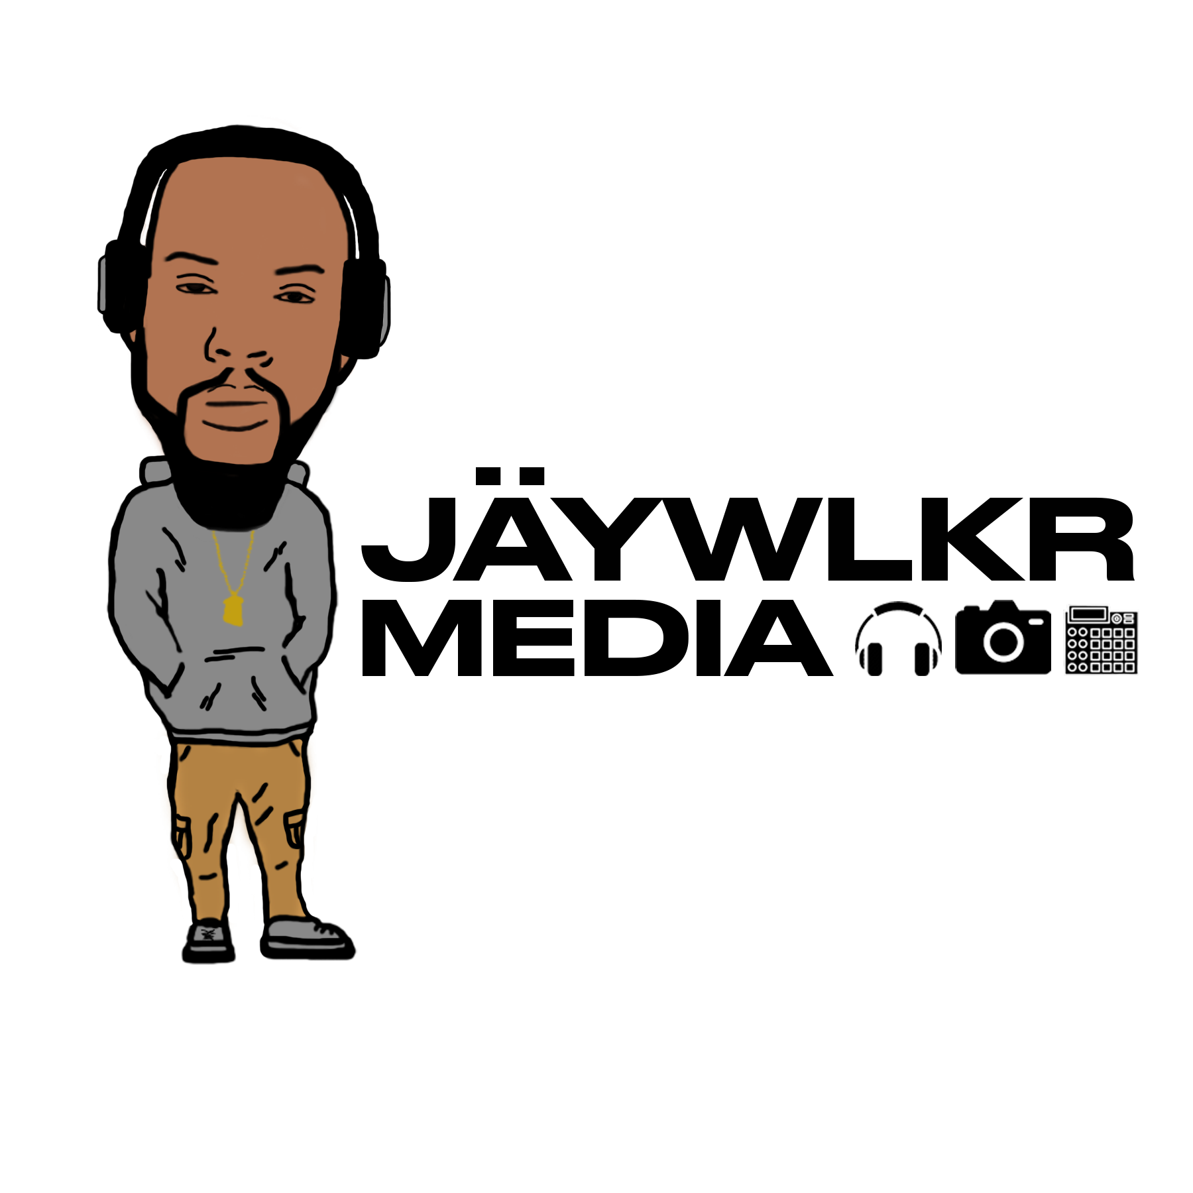
GOLD EXCLUSIVE BEAT LICENSE AGREEMENT
JÄYWLKR of JÄYWLKR (J. Walker) Media (the licensor, hereinafter referred to as the "Seller"), in accordance with the terms stated in this Agreement and for certain monetary compensation, including contingent compensation as described herein, grants:
______________________________________________________________________________ (the licensee, hereinafter referred to as the "Buyer")
rights as defined below to the following musical composition (“beat”):
______________________________________________________________________________ (name of beat) hereinafter referred to as the “Instrumental.”
RIGHTS IN THE INSTRUMENTAL GRANTED BY SELLER
The Seller grants to the Buyer limited, exclusive, non-transferable rights to use the Instrumental in the production of one “New Work.” A New Work is a composition, (“song”) created by the Buyer using the Instrumental in conjunction with substantial additional elements including lyrics, sounds synthesized or natural, instrumental tracks, vocals, or samples. Buyer is further granted the right to produce one music video incorporating the New Work.
Following the date of this agreement, the Seller shall not transfer or license any rights to parties other than Buyer to use the Instrumental for any purpose. This exclusive license, however, is subject to respecting non-exclusive licenses for the Instrumental made with other parties prior to the execution of this Agreement. Previous licensees will retain their rights in full as per Seller’s agreement with them.
RIGHTS IN THE INSTRUMENTAL RETAINED BY SELLER
The Seller maintains full copyright ownership of the Instrumental, both in its mixed and tracked- out forms. Buyer is expressly forbidden from loaning, renting, reselling, or re-assigning rights to the Instrumental, in whole or in part, to any other party. This prohibition includes the Instrumental as it is provided to the Buyer, and as the Buyer may transform it by remixing, rearranging,
excerpting fragments, or by removing any melodies, instruments, or tracks from the
Instrumental itself.

SELLER’S WARRANTY

The Seller warrants that the Instrumental contains only sounds properly licensed to the Seller or created by the Seller, and contains no samples that require third-party copyright clearance or licensing.

SCOPE AND DURATION OF LICENSE
Buyer may record, use, reproduce, distribute, perform, sell, and license the New Work in any format, in any quantity, on any medium, in any location worldwide, for any purpose.
The license is granted in perpetuity from the date of execution of this agreement, subject to the Buyer’s adherence to the terms of this Agreement.
SELLER’S RIGHTS IN THE NEW WORK
The Instrumental is not a work made for hire. Buyer agrees that the Instrumental constitutes a material contribution to the creation the New Work, and that, with the additions of the Buyer, the New Work shall become a single unitary whole, or “joint work,” with Buyer and Seller as joint authors, writers, composers, and owners of the copyright.
The ownership of the copyright shall be apportioned as follows: 50% to Seller and 50% to Buyer.
The Seller shall therefore receive, in Seller’s proportion of ownership, a share of all revenues derived from the exploitation of said copyright.

Further, the Instrumental, by its incorporation in whole or in part into the master sound recording fixing the New Work, becomes an integral part of and contribution to the master sound recording. Seller, as sole composer and creator of the Instrumental as it is supplied to Buyer in fixed in recorded form, is therefore recognized by Buyer as a performing artist on the master sound recording of the New Work and is granted joint ownership of said master sound recording.

The ownership of the master sound recording shall be apportioned as follows: 95% to Buyer and 5% to Seller.
Seller shall therefore receive, in Seller’s proportion of ownership, a share of all revenues generated from the exploitation of the master sound recording. Such compensation is due to Seller from record one without recoupment.
Buyer shall, upon request from Seller, make available to Seller accounting documents detailing the earnings derived from the exploitation of the New Work copyright and master sound recording ownerships described above.
Seller is granted the right to exhibit but not sell the New Work on the Internet or elsewhere as a part of Seller’s own marketing and promotional efforts.

BUYER’S RIGHTS IN THE NEW WORK
The Seller grants to the Buyer the express license to record, perform, display, reproduce, distribute, and sell the New Work, its master sound recording, and videos incorporating the New Work. The Buyer further has the right to grant licenses of any kind for any uses of the New Work and the master sound recording to any parties under any terms of the Buyer’s choosing. Said uses include, but are not limited to, those set forth in APPENDIX II of this agreement. These rights and licenses are granted by Seller on the condition that Seller’s full interests in the New Work and the master sound recording are preserved.
The Buyer may solely and unilaterally exercise these rights and grant these licenses on behalf of the Seller. The Buyer will promptly notify the Seller when any such exploitation of the copyright occurs, and make an accounting to Seller of the income generated thereby.

BUYER’S OBLIGATIONS
The Buyer must sign this agreement and deliver it to the Seller.
The Buyer is solely responsible for securing rights for all lyrics, samples, tracks, vocals, instrumentals, or other material added by the Buyer in conjunction with the Instrumental to create the New Work. The Buyer warrants that the Buyer
holds or will have obtained all such rights before any reproduction or distribution of the New Work occurs.
The Buyer agrees to fully indemnify and hold harmless the Seller (and Seller’s officers, agents, and employees) of and from any and all claims, demands, losses, causes of action, damage, lawsuits, judgments, including attorneys' fees and costs, arising out of or relating to the Buyer’s use or alleged use of unlicensed or improperly licensed material in the creation of the New Work. Buyer agrees to give Seller prompt notice of any such proceedings whether or not the Seller is a named party in them.
Before the New Work is reproduced, distributed, or licensed for any use, Buyer agrees to provide to Seller a signed copy of a songwriting/publishing “split sheet” for the New Work confirming Seller’s share of authorship as defined above. An acceptable format for the split sheet is provided in APPENDIX I of this agreement.
Before releasing the New Work or master sound recording for any revenue-generating purpose, Buyer shall register the New Work with Buyer’s affiliated domestic and foreign Performing Rights Organizations, identifying Seller as co-owner of the copyright in the percentage defined above.
The Buyer shall supply the Seller with a copy of the New Work, and one copy of the music video if such video is produced.
SELLER CREDIT
The Buyer shall include a credit on all physical and electronic copies of the New Work and the master sound recording acknowledging Seller’s role in the creation of the New Work. Acceptable printed credits include: “(Prod. JÄYWLKR)” and “Prod. by JÄYWLKR.” Videos or films incorporating the New Work must contain this credit. Said credit shall be provided and displayed with all deployments of the New Work on streaming and sharing services such as Pandora, Spotify, YouTube, and all similar services.

DELIVERY OF INSTRUMENTAL
Seller shall deliver an untagged, mastered Instrumental in the WAV audio file format. Tracked out files of the Instrumental shall be delivered in the WAV format. No files will be delivered until a copy of this agreement, signed by Buyer, is returned to JÄYWLKR.
DELIVERY OF NOTICES TO SELLER
Any notice or document required of Seller to the Buyer may be delivered by Mail to: JÄYWLKR MEDIA, 795 Roberts St., Reno, NV, or by e-mail at: jamar@jwalkermedia.com.
ENFORCEMENT
This agreement shall be governed and enforced under the laws of the State of NEVADA, in which JÄYWLKR (J. Walker) Media is registered.
ACCEPTANCE OF THIS AGREEMENT
Buyer signature:________________________________________________________________
Date _________________________________
Address _______________________________________________________________________
Buyer’s Printed Name _________________________________________________________
Buyer’s record label ____________________________________________________________

Seller:

JÄYWLKR Media 795 Roberts St. Reno, NV 89502
By:___________________________________________________________________________
Date: _____________

Jamar Walker: Manager

APPENDIX I
Songwriter & Composer Split Sheet
The undersigned have jointly composed and written the musical composition named below, which, with the material contributions of each composer/writer, becomes a single unitary whole, or joint work. By mutual agreement, each contributor is a joint owner of the copyright in the percentages set forth below.
Date: _____________________________________
Project: ______________________________________________________________________________
Song (composition) Title: ________________________________________________________________
Alternate title(s):
______________________________________________________________________
Contributors:
1) Name: Ja’Mar James Walker, Date of Birth: 12-10-1978
Name (AKA, DBA): JÄYWLKR, JÄYWLKR (J. Walker) Media
Address: 795 Roberts St, Reno, NV 89502
Contributor’s Split Percentage: __________ % **
Writer PRO: ASCAP Member 1641064, IPI Number 432416585

Publisher PRO: Calvada Sound Publishing, ASCAP Member , IPI Number 433953057
Description of contribution: songwriting (music) _______________________________________
______________________________________________________________________________
Signature ______________________________________________________________________
Date: ______________________________
2) Name & DOB: __________________________________________________________________
Name (AKA, DBA): _____________________________________________________________
Address: ______________________________________________________________________
Contributor’s Split Percentage: __________ %
Writer PRO & Member #: ________________________________________________________
Publisher: _____________________________________________________________________
_______________________________________________________________________

Publisher PRO & Member #: ______________________________________________________
Description of contribution: ________________________________________________________
______________________________________________________________________________
Signature ______________________________________________________________________
Date: ______________________________
Date: _____________________________________
Project: ______________________________________________________________________________
Song (composition) Title: ________________________________________________________________
Alternate title(s): _______________________________________________________________________

3) Name & DOB: __________________________________________________________________
Name (AKA, DBA): _____________________________________________________________
Address: ______________________________________________________________________
Contributor’s Split Percentage: __________ %
Writer PRO & Member #: ________________________________________________________
Publisher:
______________________________________________________________________________
Publisher PRO & Member #: ______________________________________________________
Description of contribution: ________________________________________________________
______________________________________________________________________________
Signature ______________________________________________________________________
Date: ______________________________

** If the publishing and songwriting are separately credited, JÄYWLKR will be granted 50% of the writer’s share and 50% of the publisher’s share.

APPENDIX II
PERMITTED USES OF THE NEW WORK
Buyer is permitted to use or license the New Work and the master sound recording of the New Work for any purposes, including but not limited to those set forth below. Income derived from all of these uses and licenses is subject to revenue sharing with Seller as described in the body of this Agreement.
1. Public performances of the New Work including live performances, recordings played in public venues, or transmitted via terrestrial broadcast radio; 2. Sales and other distributions of the master sound recording of the New Work including physical and downloaded electronic copies; 3. Mechanical licenses for use of the New Work, whether compulsory or negotiated; 4. Licenses to use the New Work and the master sound recording of the New Work as an element synchronized with any visual medium, including video, television (whether over the air, cable, or on the Internet), film, and DVD; 5. Licenses to use the New Work and the master sound recording of the New Work as an element of any commercial message or advertisement in any medium; 6. Licenses to use the New Work and the master sound recording of the New Work as an element in dramatic stage productions and live for-profit audio-visual presentations; 7. Licenses to use the New Work and the master sound recording of the New Work as an element in video games, electronic games, karaoke, on-hold and in-house background, and computer programs or applications (“apps”); 8. Licenses to use the New Work and the master sound recording of the New Work as an element of any Internet wed site or social media service; 9. Licenses to distribute New Work and the master sound recording of the New Work by Internet radio, internet streaming services, satellite streaming services, terrestrial radio stations simulcast on the internet, and cable radio services, including paid locker services, purchased content lockers, mixed media bundles, and limited offerings interactive services, whether fee-based or advertiser-supported; and whether interactive, non-interactive, or on- demand. 10. Monetized and non-monetized plays of the master sound recording and videos containing the master sound recording of the New Work on YouTube, Vimeo, JW Player, SocialCam, Animoto, Deezer, Beats, Soundcloud, or other similar sharing services, whether advertising, subscription, or fee-based.

