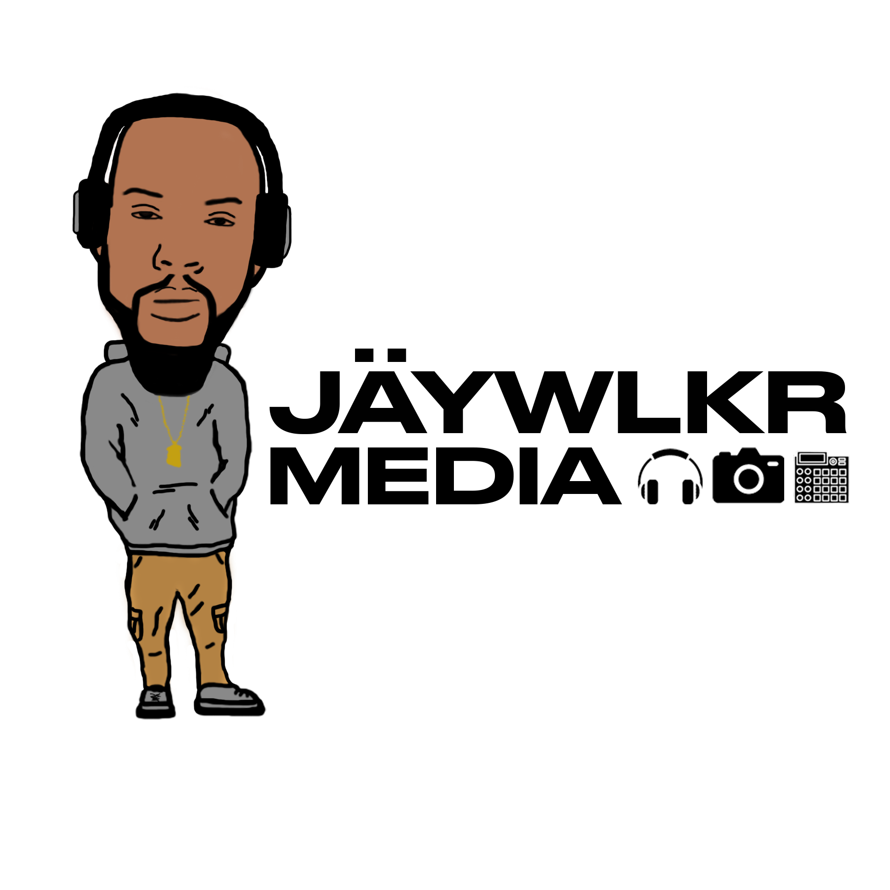
THIS PREMIUM LICENSE AGREEMENT is made on Mon, 01 Jan 2018 11:30:30 -0500
("Effective Date") by and between John Doe (hereinafter referred to as the "Licensee"), and Jamar J. Walker ("Producer"). (hereinafter referred to as the "Licensor"). Licensor warrants that it controls the mechanical rights in and to the copyrighted musical work entitled Beat Title ("Beat") as of and prior to the date first written above. The Beat, including the music thereof, was composed by Jamar J. Walker, who is professionally known as JÄYWLKR.

This Agreement is issued solely in connection with and for Licensee's use of the Beat
pursuant and subject to all terms and conditions set forth herein.

1. License Fee

The Licensee shall make payment of the License Fee to Licensor on the date of this
Agreement. All rights granted to Licensee by Licensor in the Beat are conditional upon
Licensee’s timely payment of the License Fee. The License Fee is a one-time payment for the rights granted to Licensee and this Agreement is not valid until the License Fee has been paid.

2. Delivery of the Beat

Licensor agrees to deliver the Beat as high quality, so called “untagged”, WAV file
as such terms are understood in the music industry. Licensor shall use commercially reasonable efforts to deliver the Beat to Licensee immediately after payment of the License Fee is made. Licensee will receive the Beat via email, to the address Licensee provided to Licensor.

3. Term

The Term of this Agreement shall be ten (10) years and this license shall expire on the ten (10) year anniversary of the Effective Date.

4. Use of the Beat

In consideration for Licensee’s payment of the License Fee, the Licensor hereby grants
Licensee a limited non-exclusive, non-transferable license and the right to incorporate,
include and/or use the Beat in the preparation of one (1) “New Song.” Licensee may create the New Song by recording his/her written lyrics over the Beat. The new song created by the Licensee which incorporates some or all of the Beat shall hereinafter be referred to as the “New Song”. Permission is granted to Licensee to modify the arrangement, length, tempo, or pitch of the Beat in preparation of the New Song for public release. Licensee is not allowed to add new instrumentation to the beat or modify the Beat without written consent of the Licensor.
This License grants Licensee a worldwide, non-exclusive license to use the Beat as
incorporated in the New Song in the manners and for the purposes expressly provided for herein, subject to the sale restrictions, limitations and prohibited uses stated in this
Agreement.

Licensee acknowledges and agrees that any and all rights granted to Licensee in the Beat pursuant to this Agreement are on a non-exclusive basis and Licensor shall continue to license the Beat upon the same or similar terms and conditions as this Agreement to other potential third-party licensees.

i. Distribution: The Licensor hereby grants to Licensee a non-exclusive license to use the
New Song in the reproduction, duplication, manufacture, and distribution of phonograph
records, cassette tapes, compact disk, digital downloads, other miscellaneous audio and
digital recordings, and any lifts and versions thereof (collectively, the "Recordings", and
individually, a "Recording") worldwide for up to the pressing or selling a total of Five
Thousand (5,000) copies of such Recordings or any combination of such Recordings.

ii. Streaming: Additionally, licensee shall be permitted to distribute unlimited free internet
downloads or streams for non-profit and non-commercial use. This license allows up to One hundred Thousand (100,000) monetized audio streams to sites like Spotify, RDIO,
Rhapsody but not eligible for monetization on YouTube.

iii. Synchronization: The Licensor hereby grants limited synchronization rights for One (1) music video streamed online (Youtube, Vimeo, etc..) for up to 100,000 monetized video streams on all total sites but not eligible for monetization on YouTube. A separate synchronisation license will need to be purchased for distribution of video to Television, Film or Video game.

iv. Broadcasting: The Licensor hereby grants to Licensee broadcasting rights up to 2 Radio Stations.

v. Live Performances: The Licensor hereby grants to Licensee a non-exclusive license to
use the New Song in unlimited non-profit performances, shows, or concerts. Licensee is
granted the right to receive compensation from performances with this license.

For clarity and avoidance of doubt, the Licensee does NOT have the right to sell the Beat in the form that it was delivered to Licensee. The Licensee must create a New Song for its rights under this provision to vest. Any sale of the Beat in its original form by Licensee shall be a material breach of this Agreement and the Licensee shall be liable to the Licensor for damages as provided hereunder.

Subject to the Licensee’s compliance with the terms and conditions of this Agreement,
Licensee shall not be required to account or pay to Licensor any royalties, fees, or monies paid to or collected by the Licensee, or which would otherwise be payable to Licensor in connection with the use/exploitation of the New Song as set forth in this Agreement.

5. Restrictions on the Use of the Beat

Licensee hereby agrees and acknowledges that it is expressly prohibited from taking any
action(s) and from engaging in any use of the Beat or New Song in the manners, or for the purposes, set forth below:

The rights granted to Licensee are NON-TRANSFERABLE and that Licensee may not
transfer or assign any of its rights hereunder to any third-party; Licensee shall not
synchronize, or permit third parties to synchronize, the Beat or New Song with any
audiovisual works EXCEPT as expressly provided for and pursuant to Paragraph 4(iii) of this Agreement for use in one (1) Video. This restriction includes, but is not limited to, use of the Beat and/or New Song in television, commercials, film/movies, theatrical works, video games, and in any other form on the Internet which is not expressly permitted herein. Licensee shall not have the right to license or sublicense any use of the Beat or of the New Song, in whole or in part, for any so-called “samples”.

Licensee shall not engage in any unlawful copying, streaming, duplicating, selling, lending, renting, hiring, broadcasting, uploading, or downloading to any database, servers, computers, peer to peer sharing, or other file sharing services, posting on websites, or distribution of the Beat in the form, or a substantially similar form, as delivered to Licensee. Licensee may send the Beat file to any individual musician, engineer, studio manager or other person who is working on the New Song.

As applicable to both the underlying composition in the Beat and to the master recording of the Beat: (i) The parties acknowledge and agree that the New Song is a “derivative work”, as that term is used in the United States Copyright Act; (ii) As applicable to the Beat and/or the New Song, there is no intention by the parties to create a joint work; and (iii) There is no intention by the Licensor to grant any rights in and/or to any other derivative works that may have been created by other third-party licensees.

6. Ownership

The Licensor is and shall remain the sole owner and holder of all right, title, and interest in the Beat, including all copyrights to and in the sound recording and the underlying musical compositions written and composed by Licensor. Nothing contained herein shall constitute an assignment by Licensor to Licensee of any of the foregoing right. Licensee

may not,under any circumstances, register or attempt to register the New Song and/or the Beat with the U.S. Copyright Office. The aforementioned right to register the New Song and/or the Beat shall be strictly limited to Licensor. Licensee will, upon request, execute, acknowledge and deliver to Licensor such additional documents as Licensor may deem necessary to evidence and effectuate Licensor’s rights hereunder, and Licensee hereby grants to Licensor the right as attorney-in-fact to execute, acknowledge, deliver and record in the U.S. Copyright Office or elsewhere any and all such documents if Licensee shall fail to execute same within five (5) days after so requested by Licensor.

For the avoidance of doubt, you do not own the master or the sound recording rights in the New Song. You have been licensed the right to use the Beat in the New Song and to
commercially exploit the New Song based on the terms and conditions of this Agreement.

Notwithstanding the above, you do own the lyrics or other original musical components of the New Song that were written or composed solely by you.

7. Writer’s Share and Publishing Rights

With respect to the publishing rights and ownership of the underlying composition embodied in the New Song, the Licensee and the Licensor hereby acknowledge and agree that the underlying composition shall be owned/split between them as follows:

i. Licensee shall own and control Fifty Percent (50%) of the so-called “Writer’s Share” of
the underlying composition. Specifically, the Lyrics.

ii. Licensor shall own and control Fifty Percent (50%) of the so-called “Writer’s Share” of
the underlying composition. Specifically, the Music.

iii. Licensor shall own, control, and administer Fifty Percent (50%) of the so-called
“Publisher’s Share” of the underlying composition embodied in the New Song.

8. Registering the New Song with your PRO

In the event that Licensee wishes to register his/her interests and rights to the underlying
composition of the New Song with their Performing Rights Organization (“PRO”), Licensee must simultaneously identify and register the Licensor’s / Producer’s share and ownership interest in the composition to indicate that Licensor wrote and owns 50% of the composition in the New Song and as the owner of 50% of the Publisher’s share of the New Song.

Name: Jamar Walker
PRO: ASCAP
MEMBER: 1641064
IPI #: 377933903

9. Consideration

In consideration for the rights granted under this agreement, Licensee shall pay to licensor the sum of One Hundred ($50) US dollars and other good and valuable consideration, payable to "Jamar J. Walker", receipt of which is hereby acknowledged. If the Licensee fails to account to the Licensor, timely complete the payments provided for hereunder, or perform its other obligations hereunder, including having insufficient bank balance, the licensor shall have the right to terminate License upon written notice to the Licensee. Such termination shall render the recording, manufacture and/or distribution of Recordings for which monies have not been paid subject to and actionable infringements under applicable law, including, without limitation, the United States Copyright Act, as amended.

10. Credit

Licensee shall have the right to use and permit others to use Licensor’s (“Producer”)
approved name, approved likeness, and other approved identification and approved
biographical material concerning the Producer solely for purposes of trade and otherwise
without restriction solely in connection with the New Song recorded hereunder. Licensee
shall use best efforts to have Producer credited as a “producer” and shall give Producer
appropriate production and songwriting credit on all compact discs, record, music video, and digital labels or any other record configuration manufactured which is now known or created in the future that embodies the New Song created hereunder and on all cover liner notes, any records containing the New Song and on the front and/or back cover of any album listing the New Song and other musician credits. Licensee shall use its best efforts to ensure that Producer is properly credited and Licensee shall check all proofs for accuracy of credits, and shall use its best efforts to cure any mistakes regarding Producer's credit. In the event of any failure by Licensee to issue credit to Producer, Licensee must use reasonable efforts to correct any such failure immediately and on a prospective basis. Such credit shall be in substantial form: “Produced by JÄYWLKR”.

11. Breach by Licensee

Licensee shall have five (5) business days from its receipt of written notice by Licensor
and/or Licensor’s authorized representative to cure any alleged breach of this Agreement by Licensee. Licensee’s failure to cure the alleged breach within five (5)

business days shallresult in Licensee’s default of its obligations, its breach of this Agreement, and at Licensor's sole discretion, the termination of Licensee’s rights hereunder.

If Licensee engages in the commercial exploitation and/or sale of the Beat or New Song
outside of the manner and amount expressly provided for in this Agreement, Licensee shall be liable to Licensor for monetary damages in an amount equal to any and all monies paid, collected by, or received by Licensee, or any third party on its behalf, in connection with such unauthorized commercial exploitation of the Beat and/or New Song.

Licensee recognizes and agrees that a breach or threatened breach of this Agreement by Licensee give rise to irreparable injury to Licensor, which may not be adequately
compensated by damages. Accordingly, in the event of a breach or threatened breach by the Licensee of the provisions of this Agreement, Licensor may seek and shall be entitled to a temporary restraining order and preliminary injunction restraining the Licensee from violating the provisions of this Agreement. Nothing herein shall prohibit Licensor from pursuing any other available legal or equitable remedy from such breach or threatened breach, including but not limited to the recovery of damages from the Licensee. The Licensee shall be responsible for all costs, expenses or damages that Licensor incurs as a result of any violation by the Licensee of any provision of this Agreement. Licensee’ obligation shall include court costs, litigation expenses, and reasonable attorneys' fees.

12. Warranties, Representations and Indemnification

Licensee hereby agrees that Licensor has not made any guarantees or promises that the Beat fits the particular creative use or musical purpose intended or desired by the Licensee. The Beat, its sound recording, and the underlying musical composition embodied therein, are licensed to the Licensee “as is” without warranties of any kind or fitness for a particular purpose.

Licensor warrants and represents that he has the full right and ability to enter into this
agreement, and is not under any disability, restriction, or prohibition with respect to the grant of rights hereunder. Licensor warrants that the manufacture, sale, distribution, or other exploitation of the New Song hereunder will not infringe upon or violate any common law or statutory right of any person, firm, or corporation; including, without limitation, contractual rights, copyrights, and right(s) of privacy and publicity and will not constitute libel and/or slander.

Licensee warrants that the manufacture, sale, distribution, or other exploitation of the New Song hereunder will not infringe upon or violate any common law or statutory right

of any person, firm, or corporation; including, without limitation, contractual rights, copyrights, and rights of privacy and publicity and will not constitute libel and/or slander. The foregoing notwithstanding, Licensor undertakes no responsibility whatsoever as to any elements added to the New Song by Licensee, and Licensee indemnifies and holds Licensor harmless for any such elements.

Licensor warrants that he did not “sample” (as that term is commonly understood in the
recording industry) any copyrighted material or sound recordings belonging to any other
person, firm, or corporation (hereinafter referred to as “Owner”) without first having notified Licensee. Licensee shall have no obligation to approve the use of any sample thereof; however, if approved, any payment in connection therewith, including any associated legal clearance costs, shall be borne by Licensee. Knowledge by Licensee that “samples” were used by Licensor which were not affirmatively disclosed by Licensor to Licensee shall shift, in whole or in part, the liability for infringement or violation of the rights of any third party arising from the use of any such “sample” from Licensor to Licensee.

Parties hereto shall indemnify and hold each other harmless from any and all third party
claims, liabilities, costs, losses, damages or expenses as are actually incurred by the
non-defaulting party and shall hold the non-defaulting party, free, safe, and harmless against and from any and all claims, suits, demands, costs, liabilities, loss, damages, judgments, recoveries, costs, and expenses; (including, without limitation, reasonable attorneys' fees), which may be made or brought, paid, or incurred by reason of any breach or claim of breach of the warranties and representations hereunder by the defaulting party, their agents, heirs, successors, assigns and employees, which have been reduced to final judgment; provided that prior to final judgment, arising out of any breach of any representations or warranties of the defaulting party contained in this agreement or any failure by defaulting party to perform any obligations on its part to be performed hereunder the non-defaulting party has given the defaulting party prompt written notice of all claims and the right to participate in the defense with counsel of its choice at its sole expense. In no event shall Licensee be entitled to seek injunctive or any other equitable relief for any breach or non-compliance with any provision of this agreement.

13. Miscellaneous

This Agreement constitutes the entire understanding of the parties and is intended as a final expression of their agreement and cannot be altered, modified, amended or waived, in whole or in part, except by written instrument (email being sufficient) signed by both parties hereto.

This license is non-transferable and is limited to the Beat specified above, and shall be
binding upon both the Licensor and the Licensee and their respective successors, assigns, and legal representatives.

This License is governed by and shall be construed under the law of The State of Nevada, without regard to the conflicts of laws principles thereof.

